Level 21 -> Level 22

The goal of this level is to analyse a program that is running automatically at regular intervals from **cron**, the time-based job scheduler. We need to look in **/etc/cron.d/** for the configuration and see what command is being executed and search for the password.

**Cron** is one of the most useful utility that we can find in any Unix-like operating system. It is used to schedule commands at a specific time. These scheduled commands or tasks are known as “Cron Jobs”. Cron is generally used for running scheduled backups, monitoring disk space, deleting files (for example log files) periodically which are no longer required, running system maintenance tasks and a lot more.

* Use cd /etc/cron.d/ to enter into this directory.
* Use ls to check for files and folder in current directory.
* Use cat to read the content of cronjob_bandit22 file. This is the file which consists the task cron is doing.

@reboot bandit22 /usr/bin/cronjob_bandit22.sh &> /dev/null

* * * * * bandit22 /usr/bin/cronjob_bandit22.sh &> /dev/null

@reboot means - To run a job **every time the server is rebooted**

**\* * * * * means -** To run a cron job at **every minute**

**And cron is doing something in cronjob_bandit22.sh file in /usr/bin/ directory.**

* So, we will check in /usr/bin/ directory by entering into it using cd command.
* And using cat command read the content of cronjob_bandit22.sh file.

It consists #! /bin/bash script i.e. bash script.

This script is reading content from the /etc/bandit_pass/bandit22 file and saving it to the file in /tmp folder.

* So, to get the password we will enter into the /tmp directory and read the content of the file using cat command.
* And hence, we got the password.

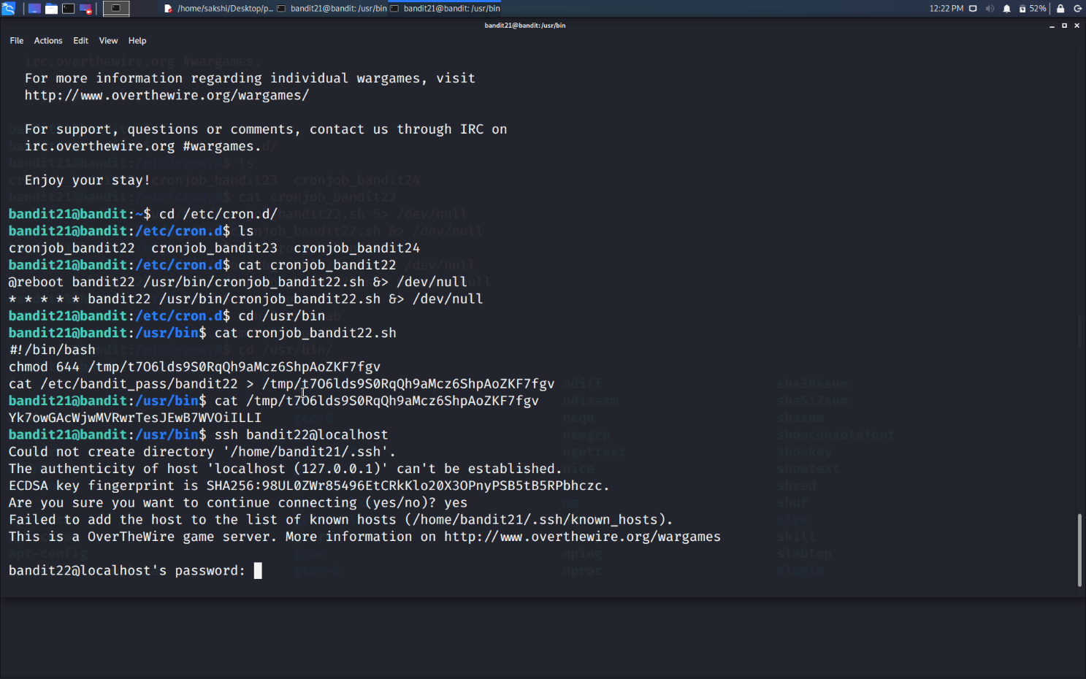

Use the command **ssh bandit22@localhost** to connect to the level 22.

Enter the password and hit enter.

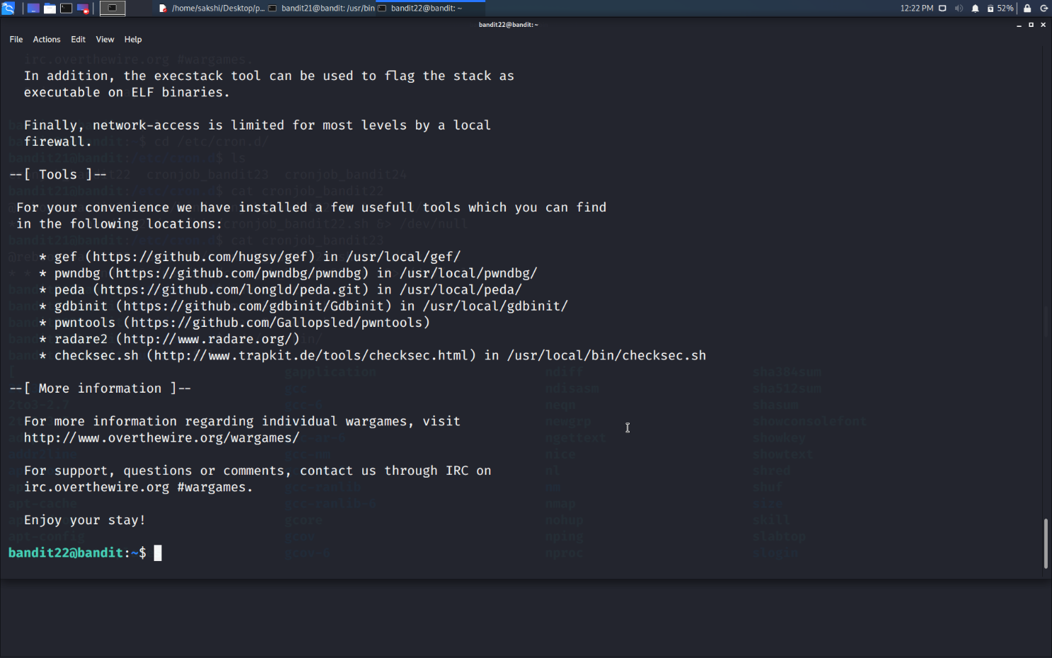

Successfully passed level 22.…